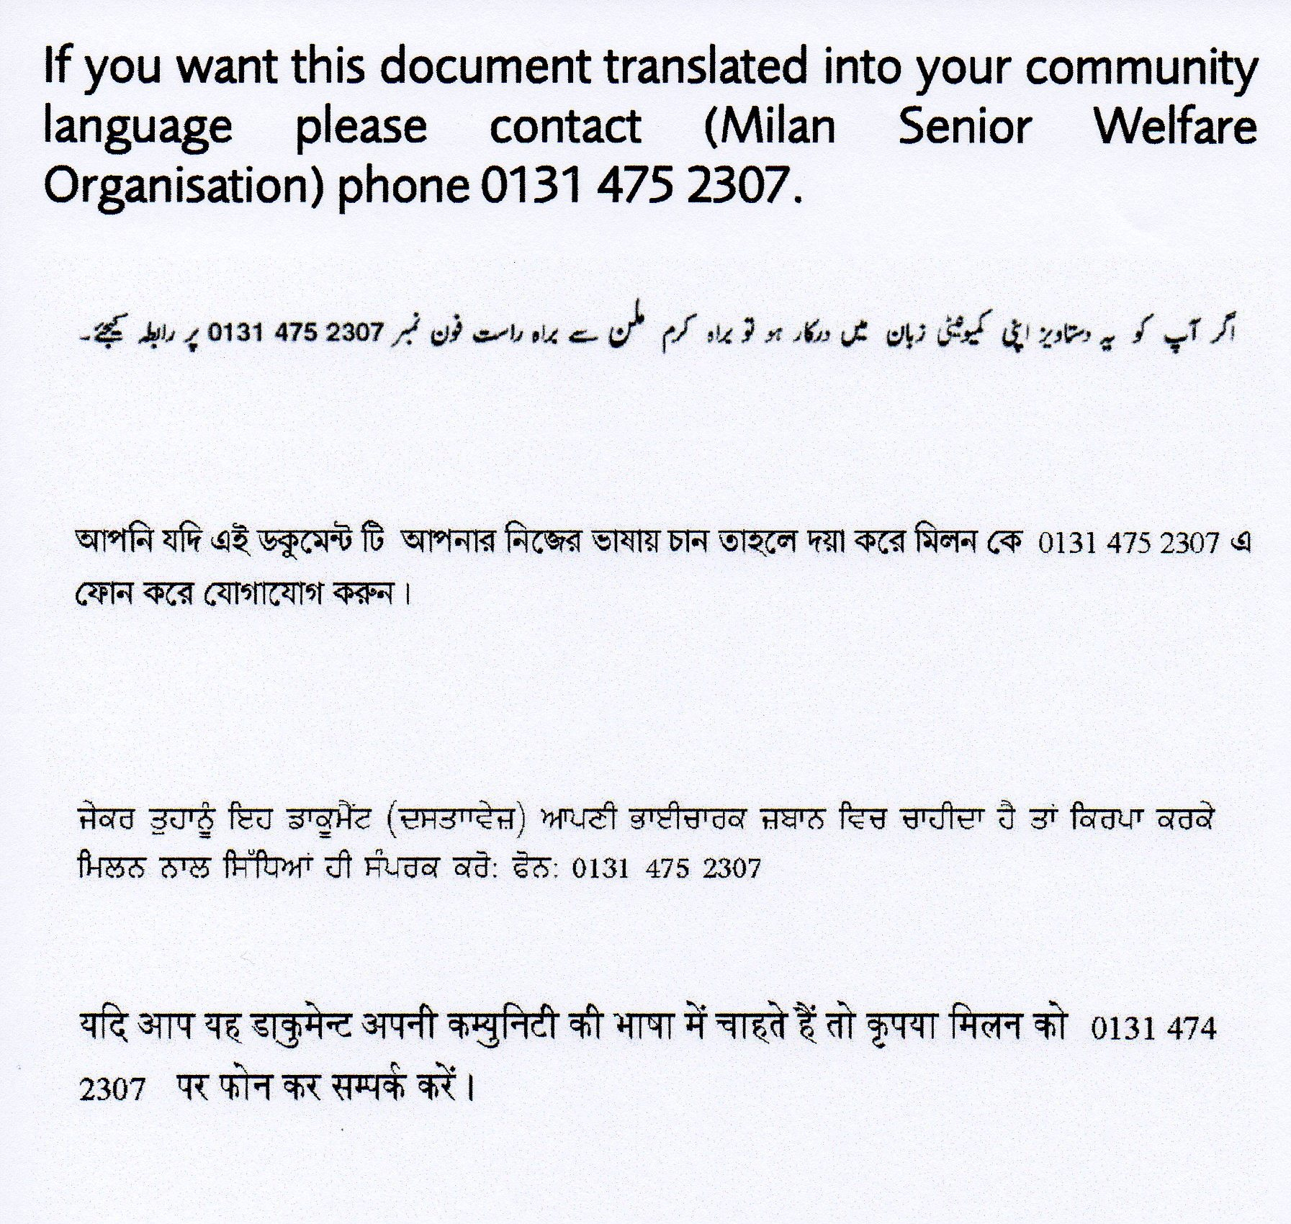


Complaint Procedure
For Service Users

For further information please contact:-
Milan (Senior Welfare Organisation) Ltd

411 Gilmerton Road, Edinburgh, EH17 7JJ
Tel: - 0131 475 2307 Email admin@milanswc.org

Website- www.milanswo.co.uk

Registered Scottish Charity No.SC023030

Milan (Senior Welfare Organisation) Ltd seeks to offer a high quality service to all its users.
However, we understand that from time to time there may be occasions when users of our services wish to make suggestions to help us to improve these services or to complain about the quality of service which they have received or wish to receive. Users’ goodwill and continued support is greatly valued by the Organisation.

Milan (Senior Welfare Organisation) Ltd wishes to ensure that everyone who uses its service is aware that they have the right to raise concerns and make complaints and we would very much like them to tell us about it. This right is yours under Section 52(5b) of the National Health Service and Community Care Act (1990).

COMPLAINTS PROCEDURE

  - Anyone who feels that they have been adversely affected by the behaviour or actions of a member of Milan (Senior Welfare Organisation) Ltd staff or Board of Directors’ while they are acting on behalf of the Organisation may make a complaint.

HOW TO MAKE A COMPLAINT

  - A complaint can be made by anyone using or wishing to use the services of Milan (Senior Welfare Organisation) Ltd.

  - A complaint can be made verbally or in writing to the Milan Secretary/Manager at the office in Norton Park, 57 Albion Road, Edinburgh, EH7 5QY; telephone 0131 475 2307, or directly to Health & Social Care Department

  - If the complaint is about the service it should be made in the first instance to the manager (verbally or written).

  - If the complaint is against a member of the Board of Directors’ or a member of staff, the complainant should raise the complaint with the Chair of the Board of Directors.

  - If the complaint is against the Chair, it should be raised with the Vice-Chair who will select other members of the Board to help them to solve the problem.

  - Where complaints are made against members of staff, it will be dealt with through the staff grievance procedures and any relevant organisational policies/procedures.

  - You can choose someone to support or to act on your behalf as an advocate. This person can assist you in whichever way is appropriate e.g. putting your complaint in writing or providing interpreting service.

  - The complaint will be acknowledged by Milan. Milan will investigate the complaint
or give a reason for any delay. In every case the complainant will be advised of any action taken as a result of their complaint.

  - All complaints together with the outcome of the complaints procedure will be recorded and reported to the Board of Directors as soon as possible after the complaints procedure has been completed.

APPEAL

  - If the complainant is not satisfied with the outcome of a complaint, they can appeal
to the Board of Directors through the Chair within 28 days. The Board will delegate
one of its members to hear the appeal and report back to the Board. The
complainant will then be informed in writing of the outcome of any appeal within 14
days of the Board Meeting.

  - Milan (Senior Welfare Organisation) Ltd welcomes the opportunity to resolve your complaint but if for any reason you are unable to contact Milan (Senior Welfare Organisation) Ltd directly or are not satisfied with the outcome of your complaint, you may contact

  - Line Service & Complaints Officer, Department for Health & Social Care, 200 Bonnington Road, Edinburgh, Midlothian, EH6 5NL
Tel: 0131 469 6222

or

  - Care Inspectorate, 3 C & D South, Victoria Quay, Edinburgh, EH6 6QQ
Tel: 0345 600 9527

